To run project, input command like this.

*npm start*

If project run, you can this screen on your browser

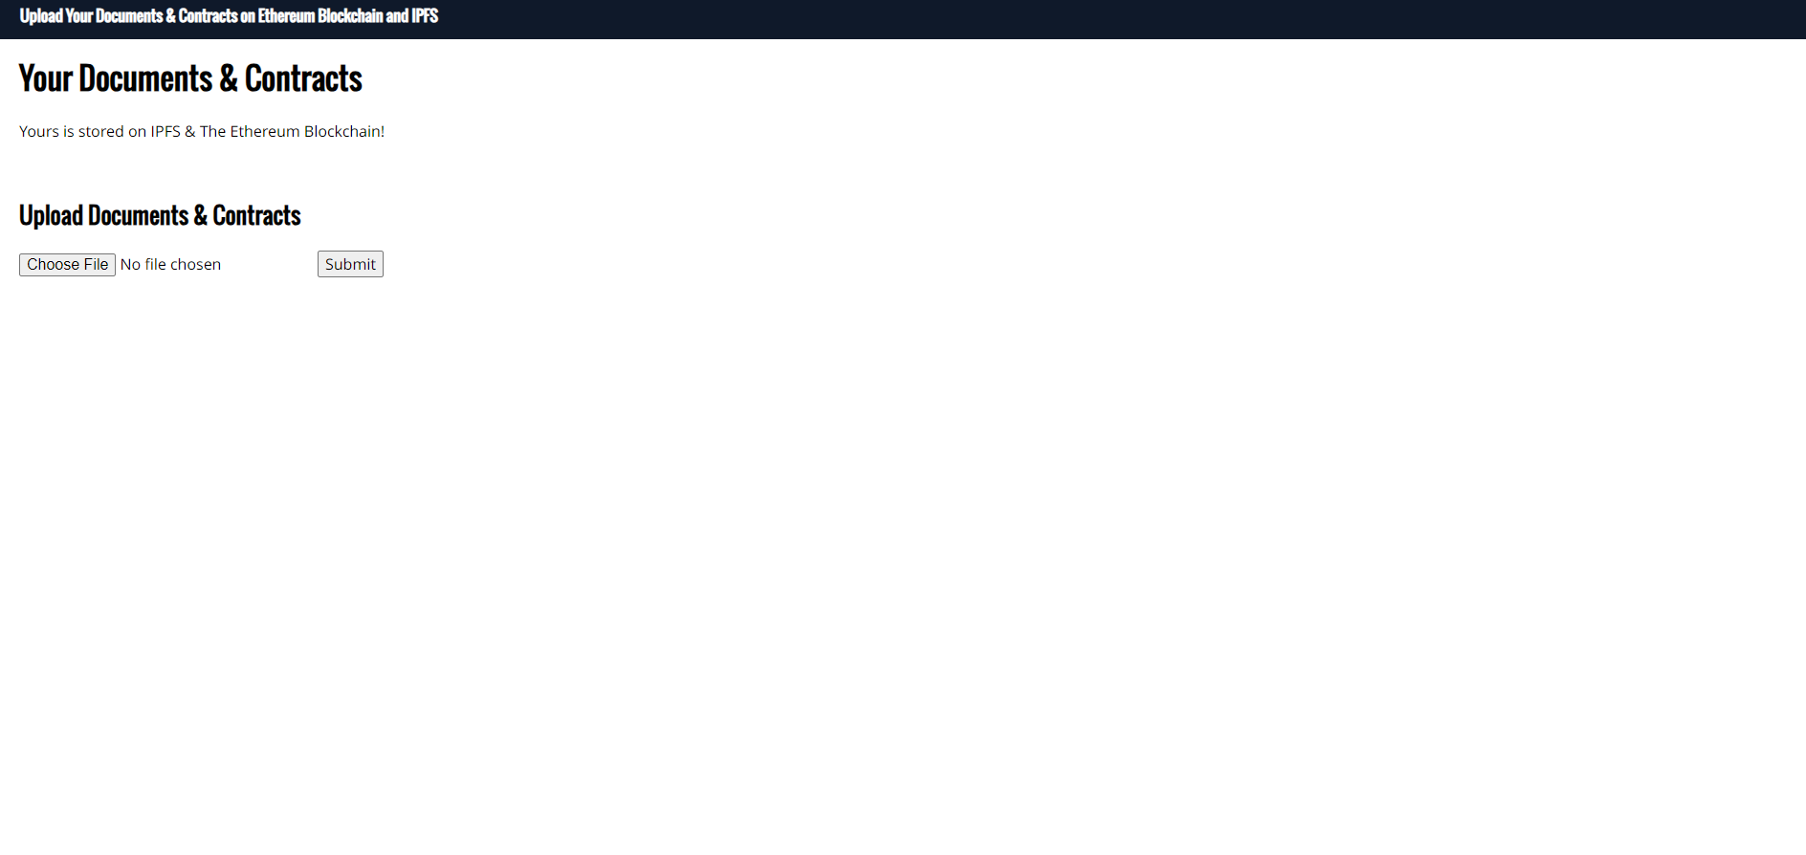

And then open your metamask wallet and connect

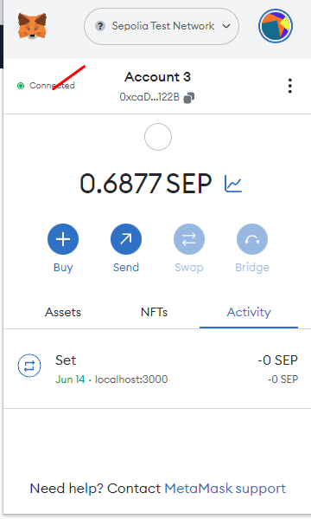

Then choose file to select file and click submit to upload

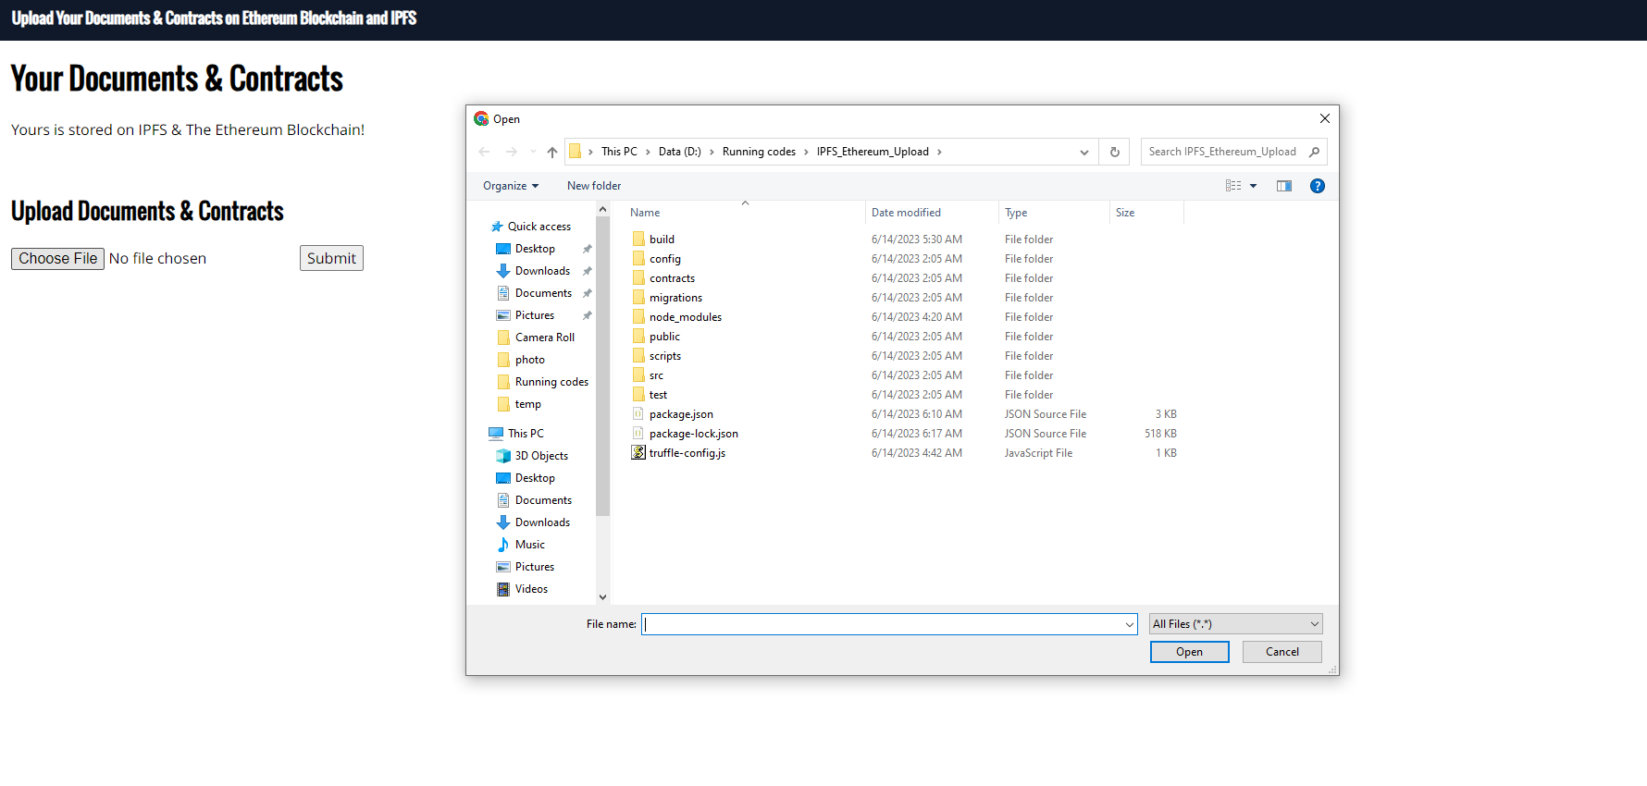

If you select file and click submit button, you can see this screen

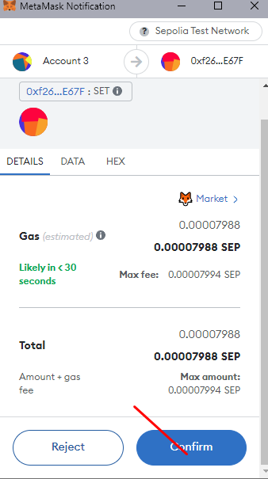

You should click confirm button and you can see notification like this

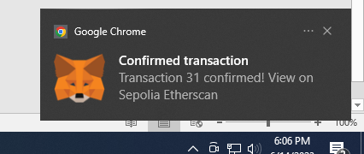

You can check transaction on this url

<https://sepolia.etherscan.io/address/0xf262710b61541f917A4535004d0DECfcD76DE67F>

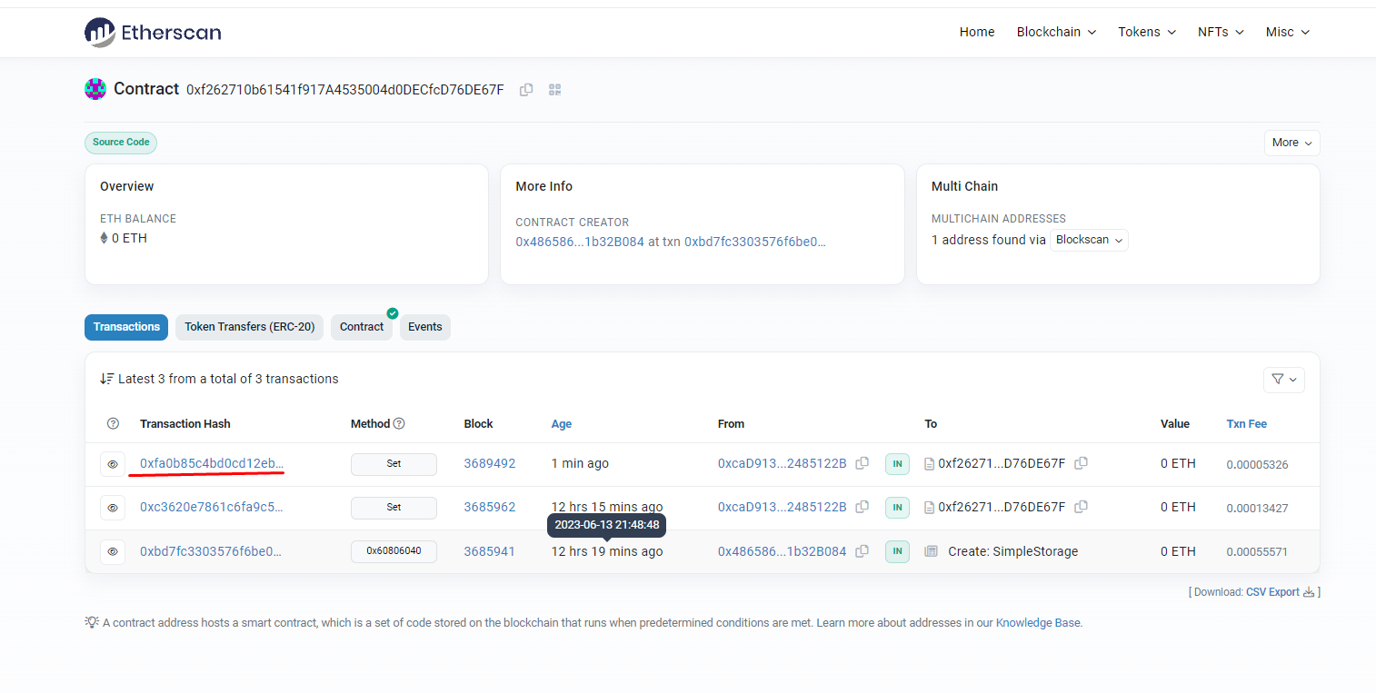

The transaction hash with red underline is last one.

(Sorry for making document not smartly.)